NAME: HABIBULLAH QURESHI
ROLL NO: 26P-3084
SECTION:B
COURSE DETAIL:CL1002

TASK 1

#include<stdio.h>
int main(){
printf("==========================================\n");
printf("\t\tFAST-NUCES STUDENT PROFILR CARD\n");
printf("===========================================\n");
int Batch=2026;
char Section='B';
float TestScore=53.03;
double SemesterFee=148500.500;
printf("Batch:%d\n",Batch);
printf("Section:%c\n",Section);
printf("TestScore:%2f\n",TestScore);
printf("SemesterFee:%f\n",SemesterFee);
printf("Motto:\t\t\"Small daily steps lead to big success\"\n");
printf("===========================================\n");
return 0;}

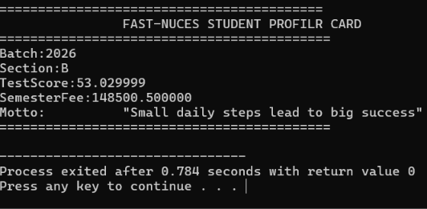

TASK 2
#include<stdio.h>
int main(){

printf("=================C ESCAPE SEQUENCES REFERENCE===================\n");
printf("1. TO print a double quote,write: \\\"\n");
printf("2. To print a literal backslash,write: \\\\\n");
printf("3. To insert a newline break ,write: \\n\n");
printf("4. To insert a horizontal tab stop,write: \\t\n ");
printf("5. To print a percent sign ,write: %%%%\n");
printf("========================================================\n");
return 0;
}

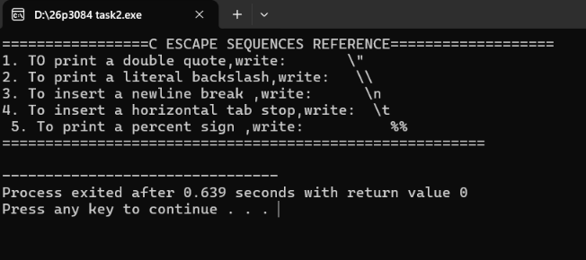

TASK 3
#include<stdio.h>
int main(){
printf("Type name\t Variable Value\t\t Size in Memory\t");
printf("\n---------------------------------------------------------\n");
printf("char \t'M' \t\t1 byte(s)\n");
printf("int\t42 \t\t 4 byte(s)\n");
printf("float \t3.141590\t 4 byte(s)\n");
printf("double\t98.765432\t 8 byte(s)");
printf("\n-----------------------------------------\n");
return 0; }

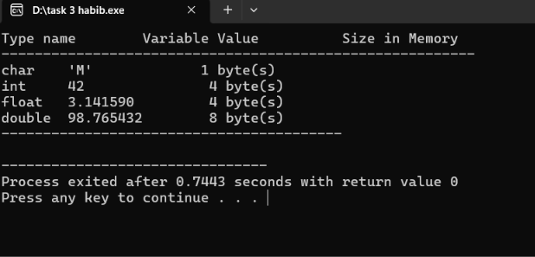

TASK 4
#include<stdio.h>
int main(){
printf("============= TEMPERATURE CONVERSION ================");
float Celsius=;375.
float Fahrenhite=(Celsius*9.0/5.0)+32.0;
float Kelvin=Celsius+273.15;
printf("\nTemperature in Celsius:\t\t%.2f",Celsius);
printf("\nTemperature in Fahrenhite:\t%.2f",Fahrenhite);
printf("\nTemperature in Kelvin:\t\t%.2f",Kelvin);
printf("\n==============================================\n");
return 0;
}
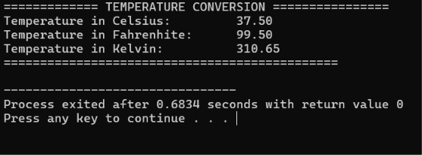

TASK 5
#include<stdio.h>
int main(){
float radius=7.5;
float pi=3.14159;
float Diameter=2*radius;
float Circumference=2* pi*radius;
float Area=pi*radius*radius;
printf("=============CIRCLE GEOMETRY REPORT=================\n");
printf("Given Radius:\t%.3fcm.\n",radius);
printf("Calculated Diameter:\t%.3fcm.\n",Diameter);
printf("Calculated Circumference:\t%.3fcm.\n",Circumference);
printf("Calculated Area:\t%.3fsq.cm.\n",Area);
printf("\n=======================================\n");
return 0;
}
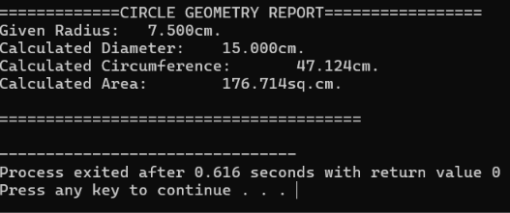
TASK 6
#include<stdio.h>
int main(){
float vi=12.5;
float a=3.2;
float t=6.0;
float vf=vi+(a*t);
float s=(vi*t)+(0.5*a*t*t);
printf("\n=============KINEMATICS MOTION REPORT============");
printf("\nInitial Velocity(vi):\t%.2fm/s",vi);
printf("\nAcceleration(a):\t%.2fm/s^2",a);
printf("\nTime Elapsed(t):\t%.2fs",t);
printf("\n-------------------------------------------------------");
printf("\nCalculated Final Velocity(vf):\t%.2fm/s",vf);
printf("\nCalculated Distance(s):\t%.2fm",s);
printf("\n================================================");
return 0;

}

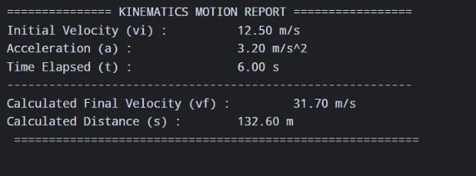
TASK 7
C#include<stdio.h>
int main(){
double principal=250000.00;
float rate=8.5;
int time=3;
float I=(principal*rate*time)/100.0;
float A= principal+I;
float MI =A/(time*120);
printf("\n=========== BANK LOAN INTEREST SUMMARY=============");
printf("\nPrincipal Amount:%.2f",principal);
printf("\nAnnual Interest Rate:%.2f%%",rate);
printf("\nLoan Duration:%d years(36 Months)",time);
printf("\n----------------------------------------------------------");
printf("\nTotal Accrued Interest:PKR %.2f",I);
printf("\nTotal Payable Amount:PKR %.2f",A);
printf("\nMonthly Installment:PKR %.2f",MI);
printf("\n===================================================");
return 0;}

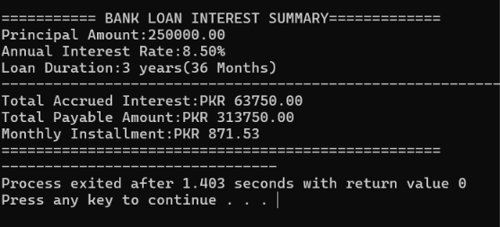

TASK 8
#include<stdio.h>
int main(){
double basic_salary=85000.00;
float HRA=(0.20*basic_salary);
float MA=(0.10*basic_salary);
float GrossSalary=basic_salary+HRA+MA;
float TD=(0.05*GrossSalary);
float NS=(GrossSalary-TD);
printf("\n=============MONTHLY SALARY SLIP=================");
printf("\nbasic salary:\tPKR%.2f",basic_salary);
printf("\nHRA(20%):\tPKR%.2f",HRA);
printf("\nMA(10%):\t\tPKR%.2f",MA);
printf("\n--------------------------------------------------------------------");
printf("\nGrossSalary:\tPKR%.2f",GrossSalary);
printf("\nTD(5%):\t\tPKR%.2f",TD);
printf("\n---------------------------------------------------------------------");
printf("\nNS:\tPKR%.2f",NS);
printf("\n======================================================================");
return 0;
}
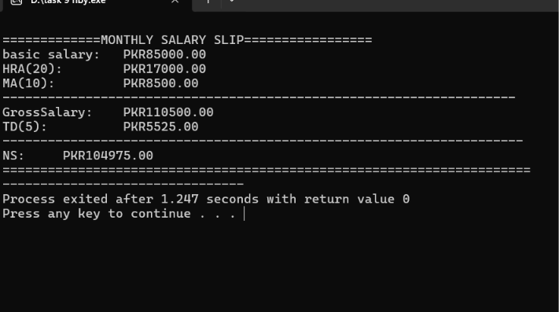
TASK9
#include<stdio.h>
int main(){
printf("==============SEMESTER ACADEMIC REPORT=================\n");
float PF_Marks=88.00;
int PF_credit_Hours=3;
float Calculus_Marks=76.5;
int Calculus_credit_Hours=3;
float Applied_physics=82.0;
int Applied_Physics_credit_Hours=2;
float Total_Weightage_Score=(88.0*3)+(76.5*3)+(82.0*2);
int Total_Credit_Hours=8;
float Weightage_Average_Percentage=Total_Weightage_Score/Total_Credit_Hours;
printf("Courses\t\tCredit Hours\t\tObtained Marks\n");
printf("------------------------------------------------------\n");
printf("Programming Fund.\t%d\t\t%.2f\n",PF_credit_Hours,PF_Marks);
printf("Calculus\t\t%d\t\t%.2f\n",Calculus_credit_Hours,Calculus_Marks);
printf("Applied Physics\t\t%d\t\t%.2f\n",Applied_Physics_credit_Hours,Applied_physics);
printf("-------------------------------------------------------\n");
printf("Total Credits:\t%d\tWeightage Average:\t%.2f%%\n",Total_Credit_Hours,Weightage_Average_Percentage);
printf("========================================================");
return 0;

}
TASK 10
#include <stdio.h>
int main() {
int Tea_Quantity=3;
float Tea_price=60.00;
float tea_total=3*60.00;
int Samosa_Quantity=4;
float Samosa_price=40.50;
float Samosa_total=4*40.50;
int Chicken_Roll_Quantity=2;
float Chicken_Roll_price=120.00;
float Chicken_total=2*120.00;
float Bill_Subtotal=(60.00 * 3) + (40.50 * 4) + (120.00 * 2);
float GST = 0.16 * Bill_Subtotal;
float Grand_Total = Bill_Subtotal + GST;
printf("============ FAST CAFETERIA RECEIPT ===================");
printf("\nItem\t\tQty\tUnit_Price\tSubtotal");
printf("\nTea\t\t%d\t%.2f\t\t%.2f",Tea_Quantity, Tea_price, tea_total);
printf("\nSamosa\t\t%d\t%.2f\t\t%.2f",Samosa_Quantity, Samosa_price, Samosa_total);
printf("\nChicken Roll\t%d\t%.2f\t\t%.2f", Chicken_Roll_Quantity, Chicken_Roll_price, Chicken_total);
printf("\n--------------------------------------------------------");
printf("\nSubtotal\t%.2f", Bill_Subtotal);
printf("\nGST (16%%)\t%.2f", GST);
printf("\n--------------------------------------------------------");
printf("\nGrand Total\t%.2f\n", Grand_Total);
printf("\n================= THANK YOU FOR VISIT=========================");

return 0;
}
